**Requirements Document**

**Purpose -** The purpose of developing attendance tracking system is to computerize the traditional way of taking attendance. Another purpose of this system is to reduce the burden of taking attendance for the instructor and also to eliminate duplicate data entry, errors in time and attendance entries. It improves visibility to track and manage student attendance.

**Scope:**

Our project scope is to track the student attendance by generating QR code. To elaborate, we have provided more functionalities to the department head and instructor, they can view the student attendance as well as they can see the number of students present in class on a particular day with representation of bar graph, they can manage courses as per CRN and they can add a course likewise they can remove the course too. Students can view the attendance and we have limited the access for students like one user can only scan QR code with one mac address. This system is limited to the Northwest Missouri State University.

**Functional requirements**

“A functional requirement defines a function of a system or its component. A function is described as a set of inputs, the behavior, and outputs.”

The main purpose of this project is to build an easy and a faster way to gain and track attendance of the students. The student has to scan the QR code for his attendance, the details such as student ID number, student name, student course and semester details needs to be captured.

The requirements are listed below:

· The system must allow the user to scan the QR code

· The system should be able to recognize a QR code

· The system must decode the QR code that is scanned

· The system must allow the user to capture a picture of the QR code

· The system must allow the user to send the captured QR code to the instructor

· The system should be able to capture the details of the system such as the MAC ID.

· The system should be able to connect to the database for sending and retrieving the student information

· The system should be able to show the student the registered courses

· The system should be able to allow the instructor to change the percentages of the student

· The system must allow the user to Login into the account

· The system should allow the user to register for a new account.

· The system should send a captcha everytime the user Logins into the system.

· The system should allow the instructor to generate the QR code any number of times

· The system should allow the instructor to check the number of students in the class

· The system should allow the instructor to set timer for the QR codes.

· The system should allow the user to check his attendance percentage.

· The system should allow the user to check the feedback of the attendance percentage

· The system must allow the admin to manage the instructor details

· The system must allow the instructor to generate the QR code using the CRN of the course.

**Non-Functional Requirements:**

**“**A non-functional requirement is a requirement that specifies criteria that can be used to judge the operation of a system, rather than specific behaviors.”

**Performance**: Easy tracking of attendance can be done by the instructor effortlessly.

· **Static Requirements:** These requirements do not impose any constraints on the execution characteristics of the system. They are:

a. Number of terminals: This system makes complete use of a database, while the front end will be available in the form of an application of the student and a standalone application for the instructor.

b. Number of users: The number of users for this system are mainly three they are the student, instructor and the admin who can also be referred as the department head.

· Dynamic Requirements: These specify some of the requirements which may be changed based on the constraints or the limitations of that particular requirement. They typically include response time and throughput of the system.

**Availability**: This system is available for the users of any educational institutions such as the colleges and high schools for marking the attendance of the students in an easy and flexible way.

**Security:** This system is highly secure since it allows the instructor to generate multiple QR codes and also ask for an image of the QR code scanned by the student to ensure that the student is in the class and also reduces the abuse of the system.

**Portability**: This system is an application which can be installed in any system satisfying the system requirements of the software.

**Maintainability:** Backups for the database can be done for future use.

**Use Case Diagram**

The use case diagram is usually a graphical description of interactions between the elements of a system. This is also a methodology which is used in system analysis to identify, organize and clarify the requirements of the system.

**Purpose:**

The main functionality of the use case diagram is to show in what way a user can communicate with the system, this may help in developing a prototype of the system and identifying specific requirements for that particular task. A use case diagram is similar to that of a flow chart. A use case diagram mainly consists of four basic components, they are

**Actor:** Individuals who are involved in the system, defined as per their roles.

**Use Cases:** these are said to be the specific roles played by the actors within the system or around the system.

**Boundary:** This defines the system of interest in relation with the world which is around that particular system.

**Relationships:** These are the specific relation between the actors and the use cases of the system.

A use case diagram generally consists of an actor and all the task which can be performed by the actor which are represented in the form of an oval called use cases.

In the proposed system there are mainly three actors around which the complete system is based up on they are Student, Instructor and the Admin.

**Student:**

This actor plays a major role in the system. He is responsible for login in to the system using his Student ID as his user name and using his unique password with all the constraints. He then scans the QR and captures an image of the QR and then sends it to the instructor for grading his attendance. He can also view the overall courses he is registered in to and also check the individual percentage in each of his course. He receives a feedback as soon as the code is captured and is sent to the instructor for grades.

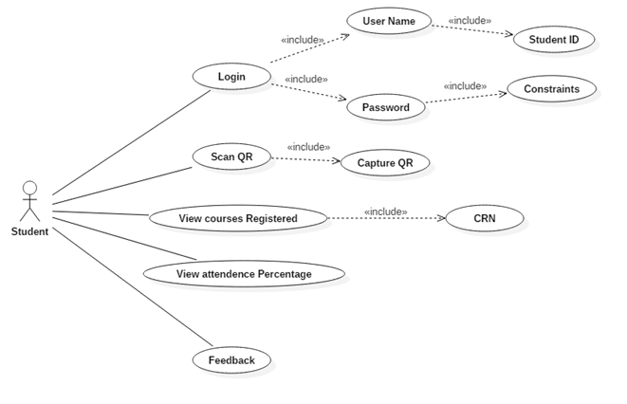

**Use Case Diagram for Student**

**Instructor:**

This actor is capable of managing the student and his attendance. He is also capable of updating the attendance details of the student. He has many vital roles such as managing the courses, managing the students, and displaying the QR codes. In the process of managing the student instructor is capable of viewing the details of the students and also check the percentage of the student and update it. In the process of managing the courses he is able to add or delete the courses with his own sections. He is also allowed to display the QR codes according to the time at which the class meets and the CRN number and he also has an access to generate multiple QR codes based on his requirements for a specific class at any point of time.

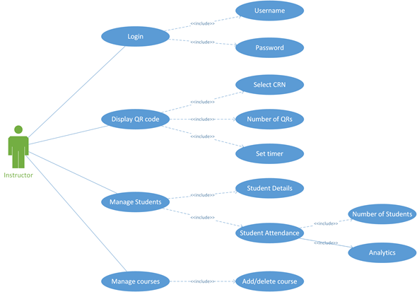

**Use case diagram for Instructor**

**Admin:**

Admin plays a kind of actor who is responsible for all the roles, he can also be defined as the head of the department. He is capable of login into the system and view different courses present in the system, capable of managing students such as check student details, students attendance, capable of managing the instructor such as checking the details of the instructor and also capable of add or deleting or the QR code for a particular course.

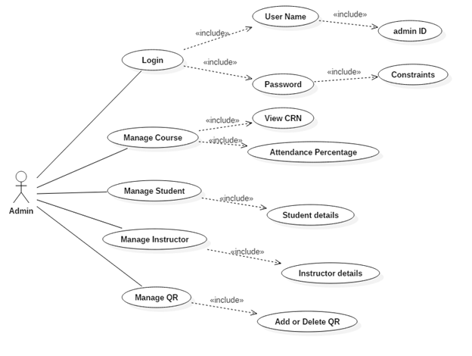

**Use case diagram for Admin**